CURRICULUM VITAE

Dr. Kanika Saha
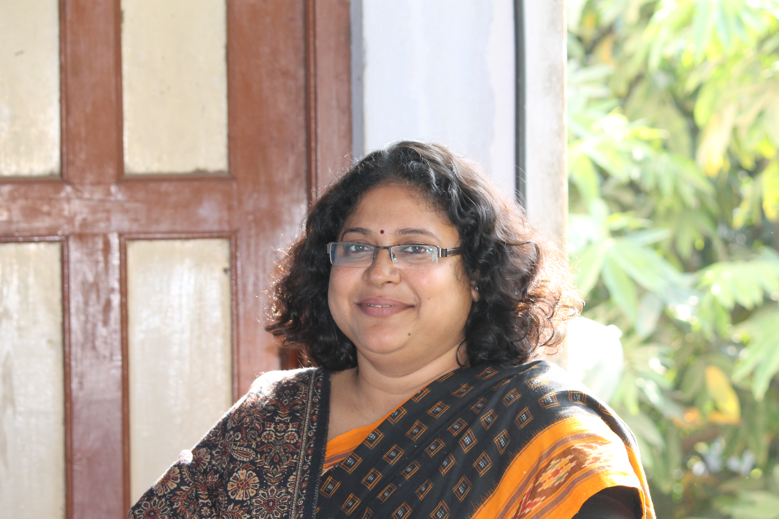
Associate Professor
Head of Geography Department.
Gushkara Mahavidyalaya.
Gushkara, Burdwan 713128
West Bengal, India.
Cell Phone No.-+91-9434037827.
Email id.-kanikasaha@yahoo.com

PERSONAL DATA
Date of birth 11 January 1975
Nationality Indian
Status Married

Residential Address 117,Tikorehat
P.O.Lakurdi
Burdwan 713102
West Bengal, India
PIN-735303
Ph: +91-342-2658426, 9475344262(M).

Language English Excellent
Bengali Mother Tongue

EDUCATION
2004 Ph.D in Arts (Geography)
Research title: Mine fire problem: A study in environmental impact of mining in the Raniganj Coalbelt, West Bengal. The University of Burdwan, West Bengal, India.

1998 M.A. in Geography (58.25%)
The University of Burdwan, Burdwan, West Bengal, India.

1996 B.A. in Geography (60%)
The University of Burdwan, Burdwan, West Bengal, India.

1993 Higher Secondary (60%)
1991 Madhyamik (68%)

PROFESSIONAL EXPRIENCE

2002 to till date Assistant Professor in Geography, Guskara Mahavidyalaya, Burdwan, and West Bengal
2000 to 2002 Part-time lecturer in MUC Women’s College

AWARDS
1999 Junior Research Fellowship (SLET).

6. DETAILS OF Orientation Programme/ Refresher Course Attended
- Participated in UGC Sponsored Orientation Programme on and from 10.10.03 to 06.11. 03 Organised by Academic Staff College, The University of Burdwan.

- Participated in UGC Sponsored Refresher Course on Environmental Studies on and from 27.01.2007 to 16.02.2007 Organised by Academic Staff College, The University of Burdwan.

- Participated in UGC Sponsored Refresher Course on Computer Application on and from 10.01.2009 to 30.01.2009 Organised by Academic Staff College, The University of Burdwan.

- Summer School (NRDMS Programme in DST) on and from 15.05.2012 to 04.06.2012 Organised by NRDMS & DST

- Participated in UGC Sponsored Refresher Course on Women Studies on and from 22.10.2013 to 11.11.2013 Organised by Academic Staff College, The University of Burdwan.

- Participated in UGC Sponsored Refresher Course on Disaster Management on and from 10.03.2015 to 30.03.2015 Organised by Academic Staff College, The University of Burdwan.

RESEARCH PROJECT CARRIED OUT:

- ‘Flood study in Guskara Town and its adjoining, Burdwan, West Bengal’UGC Sponsord from Jan 2007 to 2009(PSW-06/06-7(ERO) Nov.2006.

- Major Research Project- Project Title: The potential uses of medicinal plants along with anti microbial activities and declining forest resources threatened the tribal economy in the forest belt of Ausgram I and II CD block, Burdwan District, West Bengal. Submitted OCT 2013 NOT RECCOMENDED

3. Minor research project Tribal economy and ethno culture threatened by gradual declining of forests in Ausgram I and II CD block Burdwan District west Bengal.
Submitted to UGC on 16.08.15-Not Recommended

6. COMPUTER LITERACY AND REMOTE SENSING/GIS PROFICIENCY
- Expertise in general applications software (word processors, spreadsheets, graphical packages).

- Professional training: Successfully completed seven days course on Aerial Photography, Remote Sensing and GIS from NATMO (Calcutta), Ministry of Science and Technology, govt. of India.

- Successfully completed fifteen days course on Aerial Photography, Remote Sensing and GIS from RRSSC (Kharagpur), Dept. of Space, Govt. of India.

Foreign Travels
2006 Australlia (ANU library)
2002 The Netherlands (ITC Library)
PUBLICATIONS:
- 2005-Saha, K., Gangopadhyay, P. K. , and Bhattacharya, K.-Studies on the Environmental Impact due to coal mining Activities in Raniganj Coalbelt in Weast Bengal, Impacts of coal mining Activities on Environment: A case study in Raniganj Coalbelt West Bengal.Indian journal of Regional Science,37,pp85-95.
- 2005- Gangopadhyay, P. K., Lahiri-Dutta, K., Saha, K.,-Application of remote sensing to identify coalfires in the Raniganj Coalbelt,India.International journal of Applied Earth Observation and Geoinformation8 ?(2006) 188-195 (Available online on28 November 2005 at http://www.sciencedirect.com/)
- 2006-Gangopadhyay,P. K. ,Saha K., Van der Meeter, F. Van Dijk, P,- satellite derived emissivity to detect coalfire related surface temperature anomalies in Raniganj Coalbelt, India, in Second International Symposium on Geoinformation for Disaster Management, goa,Sept.2006, In the international Archives of Photography remote sensing and spatial informatics sciences vol.34 partxxx
- 2006-Saha, K. and Bhattacharya.-Coal Mining Coalfire and Environment: Two case studies in Raniganj and Jharia Coalfield, India. in Indian Journal of Landscape, Ecology and Ekistics, Kolkata V.29 no.1

- 2012 –use of satellite derived emissivity to detect coalfire related surface temperature anomalies in Jharia Coalfield, India, P.Gangopadhyay, Freek Van Meet, Paul M Van Dijk, Kanika Saha, International journal of Remote Sensing,33:216942-6955 Nov. 2012

- 2014-Agricultural pesticides (The essential evils) pollution on the flora of river Kunnur, Guskara, Burdwan Sunanda Mondal, Kanika Saha and Ranjan Paul Impact of pollution: “Assessment and Awareness” Mondal et al, August, 2014;50-58. ISBN: 978-81-921083-8-4.
- 2015-Effect of urbanization the hydrologic Regimes and geomorphic stability of small stream Bhagirathi Hooghly river valley. K.Saha, S. Bandopadhyay.Book of Dimension and Urbanization Environmental change and sustainable development in Developing Countries. Feb.,2015
- 2015-Abuse of Borax fertilizer:An environmental study of potatoes cultivation in Mekhliganj Block, K.Saha & R. Paul published in book of “RECENT DEVELOPMENTS in GREEN CHEMISTRY”. ISBN: 978-93-523-5350-3
- 2015- Guskara :A geographical view-K.Saha, B.Mitra and S.Pal, . Proceedings of the Golden Jubilee (1965-2015) Celebration of Gushkara Mahavidyalaya August, 2015;
ISBN: 978-93-5235-350-7, Aug.2015.
10.2015-The Kunur River floods-a wakeup call for society. . Proceedings of the Golden Jubilee (1965-2015) Celebration of Gushkara Mahavidyalaya August, 2015;
ISBN: 978-93-5235-350-7, Aug.2015.
PROCEEDING PUBLISHED PAPER PRESENTATION IN CONFERENCES:
Name of the Seminar, Conference,  Symposium, Workshop etc. | Name of the sponsoring agency | Place | Date | Title of the Paper
- Environment and sustainable development |  | Bardhaman Abhijan Samayiki | 2001 | Coalmine fire: A burning problem in Raniganj coal belt (in Bengali)
- Environment and Development |  | ILEE, Kolkata | 2006 | Tracing the Runway city: A Study of the Urban sprawl of Burdwan
- 16th West Bengal state Science & Technology Congress | DST | B .U | 28.02.2009 to 01.03.2009 | Flood study in Guskara Block and its adjoining Burdwan, West Bengal. 320
- 40th IETE-Mid-term Symposium | CSIO-Chandigarh | organised by IETE and CSIR  ICTDM-2009, | 2009 | Information Technology and Natural Disaster Management special reference to Flood, Drough and Landslide in west Bengal, p.40
- Women Study | UGC | B.U. | 2010 | Women Empowerment in west Bengal: A study in International Conference on Environment, Resource and Regional Development p.83
- Impact of Pollution: Assessment and awareness. | DST | Department of Zoology, Hooghly Women’s College, Pipulpati, Hooghly. | 14.02.2014  to  15.02.2014 | Agricultural pesticides (The essential evils) pollution on the flora of river Kunnur, Guskara, Burdwan.
- Dimension and Urbanization: Environmental change and sustainable development in Developing Countries. | UGC State Level | Hatgobinda Pur College | 17.02.2014 to 18.02.2014 | Effect of urbanization the hydrologic Regimes and geomorphic stability of small stream Bhagirathi Hooghly river valley.
- 21st West Bengal state Science & Technology Congress | The University of Burdwan& DST | The University of Burdwan | 20.02.2014  &  21.02.2014 | Declined the uses of Medicinal Plants by the Tribal People in Ausgram –I (Block),Burdwan
- Environment and Population Growth Biophysical limit and sustainability | UGC | Bankura | 21.04.2014 to 22.04.2014 | Women in environment: A study of medicinal plants by tribal women in Ausgram, Burdwan
- Empowerment of Women in Bengal: A historical perspective | UGC |  | 05.09.2014 to 06.09.2014 | Tribal women –A careful Collector of food, fodder and fuel: An experience from Ausgram Block, Burdwan
- Socio-Economic Environment of the Tribes of India with special reference to the Santals. | UGC | Department of Geography  T.H.L.S. Mahavidyalaya Mallarpur Birbhum | 19.09.2014 to 20.09.2014 | Role of Tribal Women in Recent use of Medicinal Plants in Ausgram Block-I, Burdwan
- National Seminar on “RECENT DEVELOPMENTS in GREEN CHEMISTRY”. | UGC | Gushkara Mahavidyalaya, Dept. of Chemistry, Gushkara, Burdwan | 22.03.2015 | Abuse of fertiliser: An Environmental Study of potatoes cultivation in Mekhliganj block .
- Women and Education | UGC | Viswa Bharati |  | FMR Structure and single child syndrome: micro level study among educated working women in Burdwan District

10. Seminars /Conference/Retraining Attended :11(2011-2016)
Name of the Seminar,Conference,  Retraining etc. | Name of the sponsoring agency | Place | Date
- National Workshop on Research method in social science | The Institute of Social research And Applied Anthropology | Asansol Girls College | 2-3 rd Feb 2011
- State level workshop on UGC syllabus in Geography  3.International seminar on Sustainable development | B.U  NAGI | B.U  B.U | 26-28th March 2011  Nov, 2011
4.mpact of Pollution : Assessment and awareness. | DST | Department of Zoology, Hooghly Women’s College, Pipulpati, Hooghly. | 14.02.2014  to  15.02.2014
5. 21st West Bengal state Science & Technology Congress  6.National seminar on Environment and population growth  7.National seminar on Women empowerment | DST  UGC  UGC | Burdwan University  Saradamani Zilla sammalani college Bankura  Chhatra Ramai pandit college | 20.02.2014&  21.02.2014  21-22 nd Feb 2014  5-6th Sep 2014
8 Socio-Economic Environment of the Tribes of India with special reference to the Santals. | UGC | Department of Geography  T.H.L.S. Mahavidyalaya Mallarpur Birbhum | 19.09.2014 to 20.09.2014
9.National Seminar on “RECENT DEVELOPMENTS in GREEN CHEMISTRY”. | UGC | Gushkara Mahavidyalaya, Dept. of Chemistry, Gushkara, Burdwan | 22.03.2015
10. National Seminar on “RECENT DEVELOPMENTS in GREEN CHEMISTRY”. | UGC | Gushkara Mahavidyalaya, Dept. of Chemistry, Gushkara, Burdwan | 22.03.2015
11.National seminar on Women and Education | UGC | Visa Bharati | Jan 2016

